USB or PS/2 Desktop Readers with PC Keyboard Emulation

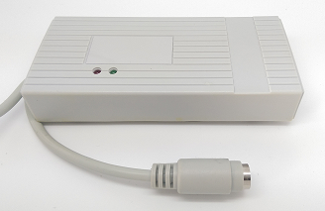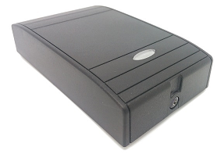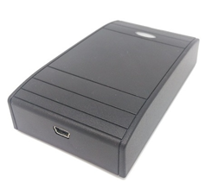
The AceProx Desktop Card Readers with USB or PS/2 interface are specially designed for the operation in a PC environment. Their internal code can be used directly in the applicable software application without any need for software modification, since it is entered at the Curser Position. Like this typing errors can be avoided and the card number does not need to be printed on the outside anymore.
All readers provide a keyboard emulation and can be plugged directly into a USB or PS/2 Port without installation of any hardware drivers. The USB versions are true Human Interface Devices (HID), so they can also be used in non-PC environments, i.e. control of photocopiers. No external power supply required.

Applications:
- Verification of passive transponder card number
- POS Systems
- PC User Authorisation
- Security & Access Control Systems as log-in unit or take-on reader
- Control of printers and photocopiers
Operating Frequency | 125 kHz | 125 kHz | 13,56 MHz | 13,56 MHz
Chips supported | EM 400X, 4102, Unique, Crosspoint | HID-Prox 26 bit & 37 bit | Mifare Ultralight, Standard 1K/4K, Plus, Desfire, NFC | Mifare Ultralight, Standard 1K/4K, Plus (SL1),NFC
Standard | - | - | ISO 14443A | ISO 14443A
Output Data String | ID-Code in Decimal, Hexadecimal or Crosspoint | Site Code and/or User Code | ID-Code in Decimal or Hexadecimal | ID-Code and/or Sector Data in various formats
Configuration by | DIP-Switch | DIP-Switch | DIP-Switch | CONFIG-Card
PS/2: Product Ref. | 732-52 | - | 734-52 | 735-52
USB*: Product Ref. | 736-52 | 728-52 | 738-52 | 737-52
USB Versions are available in light grey or black


I d e n t i f i k a t i o n s s y s t e m e G m b H

